CDAC MUMBAI

Concepts of Operating System Assignment 1

Khushi Nikhare_KH

**Problem 1: Read the instructions carefully and answer accordingly. If there is any need to insert some data then do that as well.**

1. Navigate and List:
   1. Start by navigating to your home directory and list its contents. Then, move into a directory named "LinuxAssignment" if it exists; otherwise, create it.

Commands used:

cd (to navigate to your home directory)

ls (list its content)

cd LinuxAssignment/ (to move into directory names “LinuxAssignment”)

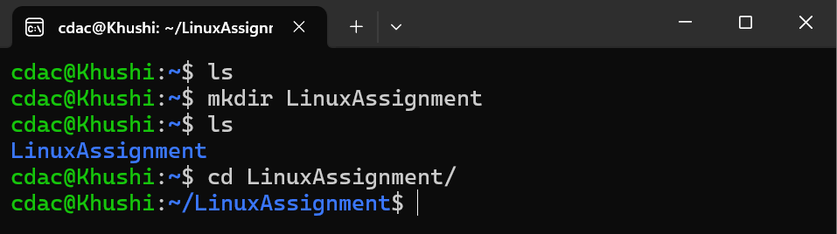

1. File Management:
   1. Inside the "LinuxAssignment" directory, create a new file named "file1.txt". Display its contents.

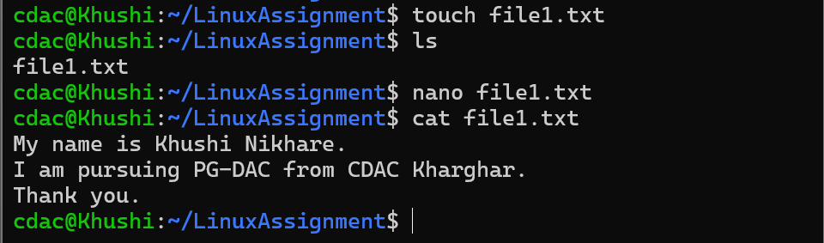

Commands used:

touch file1.txt (create a new file named “file1.txt”)

nano file1.txt (to edit file1.txt)

cat file.txt (to display the content in file1.txt)

1. Directory Management:
   1. Create a new directory named "docs" inside the "LinuxAssignment" directory.

Commands used:

mkdir docs (to create a new directory named “docs”)

ls (list out files and directories in “LinuxAssignment” directory)



1. Copy and Move Files:
   1. Copy the "file1.txt" file into the "docs" directory and rename it to "file2.txt".

Command used:

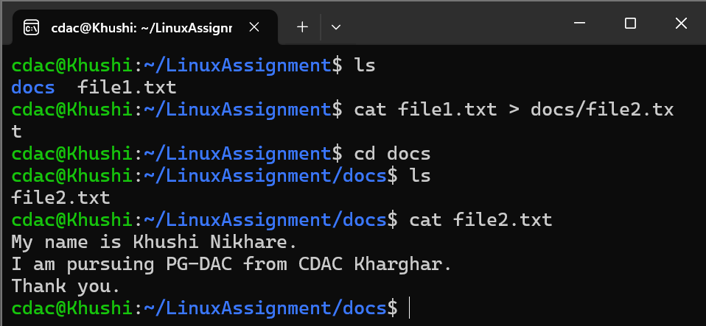cat file1.txt > docs/file2.txt (content of file1.txt is redirected to file2.txt in docs directory)

1. Permissions and Ownership:
   1. Change the permissions of "file2.txt" to allow read, write, and execute permissions for the owner and only read permissions for others. Then, change the owner of "file2.txt" to the current user.

Commands used:

chmod u+wx file2.txt

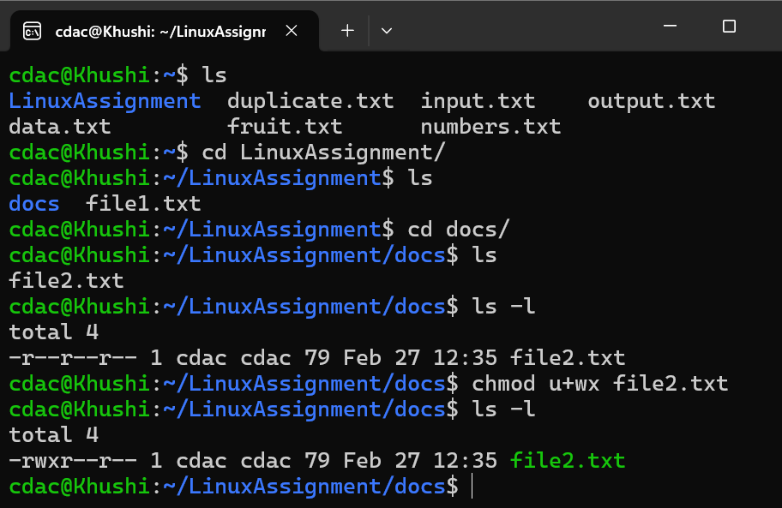

1. Final Checklist:
   1. Finally, list the contents of the "LinuxAssignment" directory and the root directory to ensure that all operations were performed correctly.

Command used:

ls

cd ..

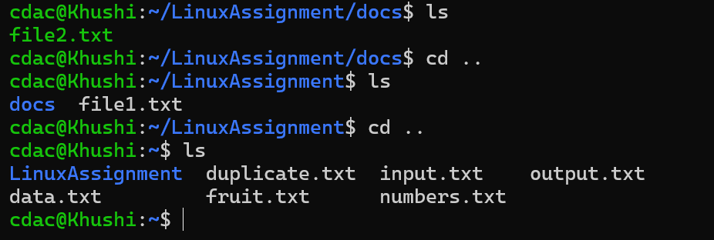

1. File Searching:
   1. Search for all files with the extension ".txt" in the current directory and its subdirectories.

Command used:

find . -name “*.txt”

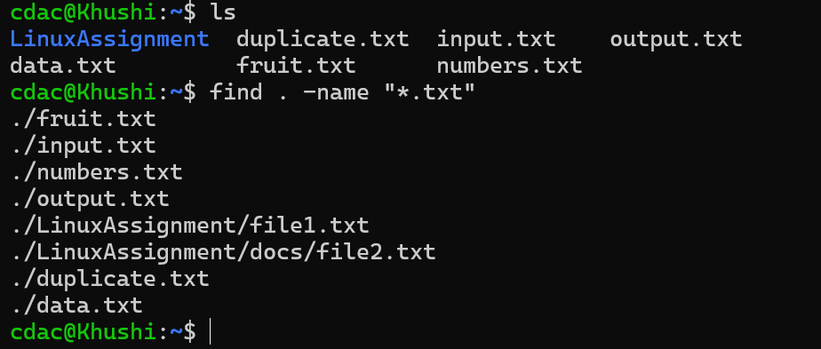

* 1. Display lines containing a specific word in a file (provide a file name and the specific word to search).

Command used:

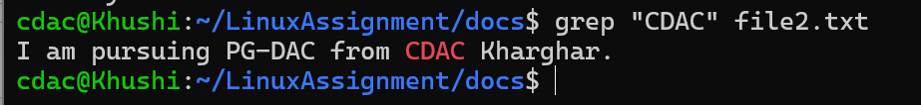grep “CDAC” file2.txt

1. System Information:
   1. Display the current system date and time.

Command used:

date

1. Networking:
   1. Display the IP address of the system.

Command used:

ifconfig

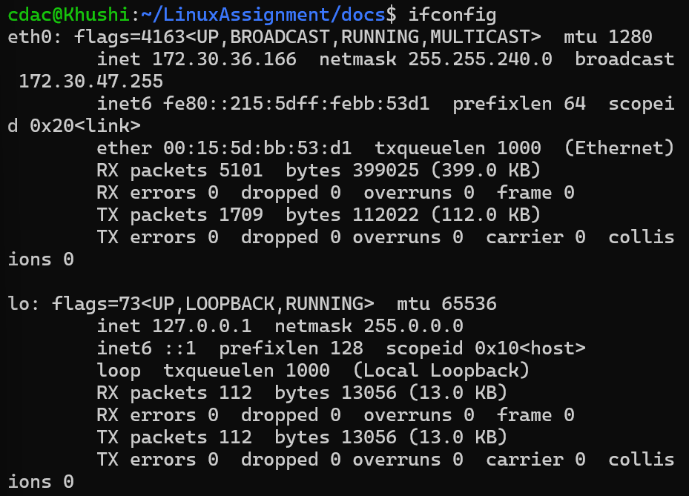

* 1. Ping a remote server to check connectivity (provide a remote server address to ping).

Command used:

ping medium.com

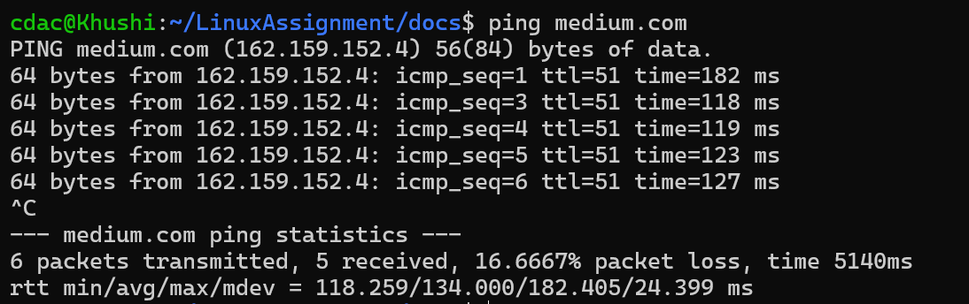

j) File Compression:

* 1. Compress the "docs" directory into a zip file.

Commands used:

Zip -r docs.zip docs

* 1. Extract the contents of the zip file into a new directory.

Commands used:

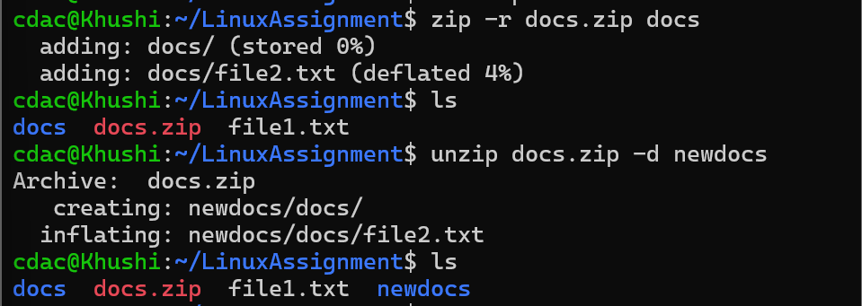unzip docs.zip -d newdocs

k) File Editing:

1. Open the "file1.txt" file in a text editor and add some text to it.

Command used:

nano file1.txt

1. Replace a specific word in the "file1.txt" file with another word (provide the original word and the word to replace it with).

Commands used:

sed -i ‘s/Khushi Nikhare/Ayushi Nikhare/g’ file1.txt

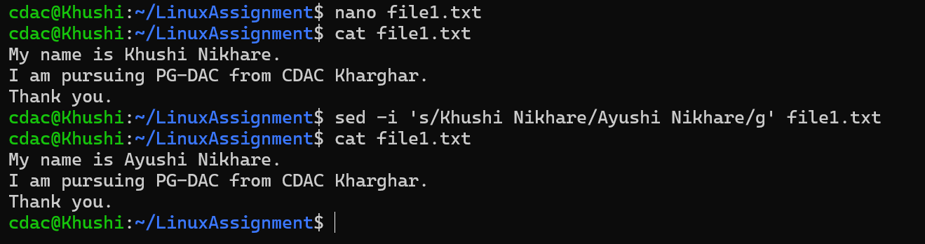

**Problem 2: Read the instructions carefully and answer accordingly. If there is any need to insert some data then do that as well.**

1. Suppose you have a file named "data.txt" containing important information. Display the first 10 lines of this file to quickly glance at its contents using a command.

Commands used:

touch data.txt

nano data.txt

head -10 data.txt

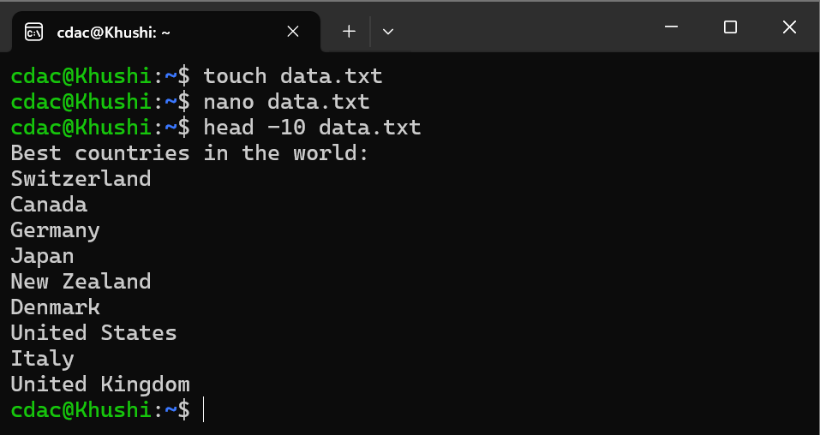

1. Now, to check the end of the file for any recent additions, display the last 5 lines of "data.txt" using another command.

Commands used:

Tail -5 data.txt



1. In a file named "numbers.txt," there are a series of numbers. Display the first 15 lines of this file to analyze the initial data set.

Command used:

nano numbers.txt

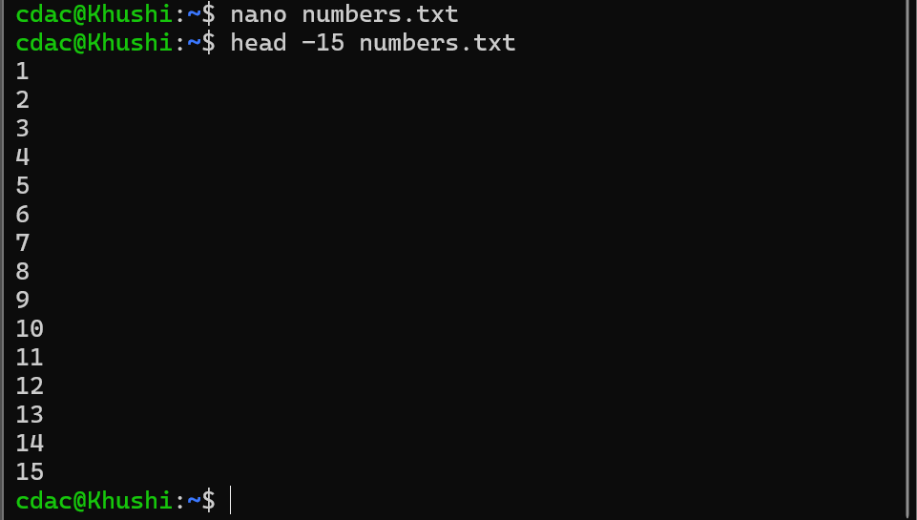 head -15 numbers.txt

1. To focus on the last few numbers of the dataset, display the last 3 lines of "numbers.txt".

Commands used:

tail -3 numbers.txt



1. Imagine you have a file named "input.txt" with text content. Use a command to translate all lowercase letters to uppercase in "input.txt" and save the modified text in a new file named "output.txt."

Commands used:

cat input.txt | tr [:lower:] [:upper”] > output.txt

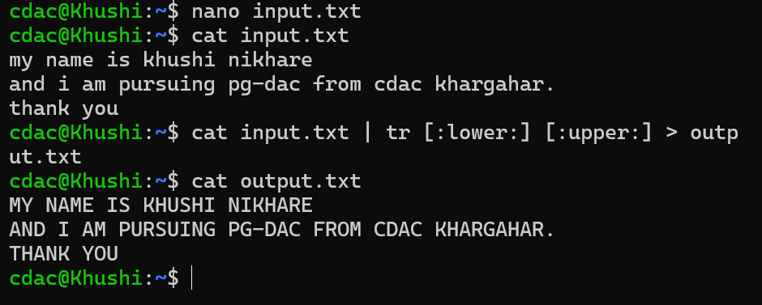

1. In a file named "duplicate.txt," there are several lines of text, some of which are duplicates. Use a command to display only the unique lines from "duplicate.txt."

Commands used:

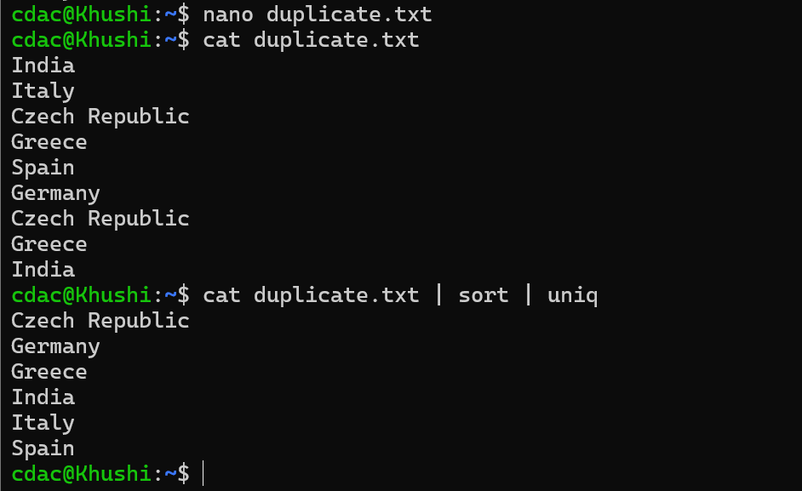Cat duplicate.txt | sort | uniq

1. In a file named "fruit.txt," there is a list of fruits, but some fruits are repeated. Use a command to display each unique fruit along with the count of its occurrences in "fruit.txt."

Commands used:

cat fruit.txt | sort | uniq -c

